Ancient Greek Theatre (This Material CAN and probably WILL be on your assessments and your final exam)
Page 810-Information:
Greek theatre was rooted in Greek___________________, which was based on a belief in many gods. Define and Learn these adjectives:

Polytheistic_____________________________Monotheistic_______________________________________ Atheistic_________________________________
Greek gods were often quick to punish human beings for being guilty of _________________ or excessive pride. They especially didn’t like it when man tried to put themselves on the same level as the gods.
The Festival of Dionysus Pages 810  Who is Dionysus?______________________________________________  What was his festival called?_____________________________________  Where:______________________________________________________  When and for how long?________________________________________  What was the original chorus at the festival?________________________  What did they chant?___________________________________________  Who was the first poet to step away from the chorus?________________  What term do we get from this guy?______________________________  What did he do when he stepped away from the chorus?______________  What was born as a result of his stepping away from the chorus?________  What did the playwright Aeschylus add to the drama party?____________  What did Sophocles add to the party?______________________________  What are the three types of plays that actors performed?  1.___________________________________________________________  2.___________________________________________________________  3.___________________________________________________________  What was the Greek word for Actor?______________________________  What is the definition of that word?_______________________________  That term is the origin of our word________________________________,  Which is a noun (hip’ uh krit). What is a hypocrite?___________________  ____________________________________________________________  ____________________________________________________________ | The Greek Theatre  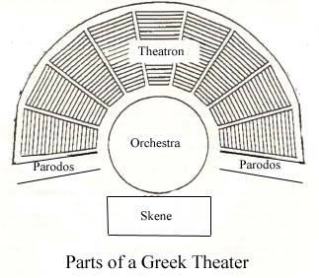 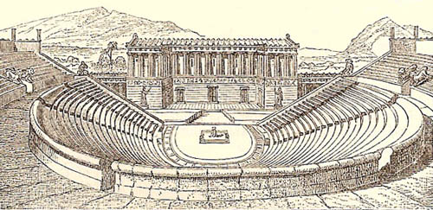  Circle the correct description of a Greek Theater  Indoor or Outdoor Near city or out in a field  Flat or on a slope In Athens or in Crete  Sat first on wood or on stone Full circle or semi-circle  Curtain or no curtain Masks or no masks  Theatron—Are of seats for the audience  Orchestra—the performance area  Parados—walled walkway used by the chorus to enter and exit. What word do we get from this word?_______________________________  Skene—building that contained the actors’ dressing rooms?  The theatre could hold 15,000 to 20,000 people. What places to see concerts or plays in Atlanta hold about the same amount of people?____________________  __________________________________________________________________
Define the Following Terms
Verse Drama | Odes | strophe
Prologue | Paean | Antistrophe
Parados | Exodus | Epode
Choragus and Chorus | Deus Ex Machina | En Media Res

The Fundamentals of a Greek Tragedy according to Aristotle, who wrote ____________________________ and lived from_______________to ________.
Term | Definitions and class notes | As it exists in Anitgone . In this section, you will document what section from the play (scene, ode, parados, etc., and page number)
Tragedy
Tragic Hero
Protagonist
Antagonist
Hamartia
Tragic flaw
Hubris
Catharsis
Read Page 813. After you are done, answer the following questions:
What are the three Theban plays? 1_______________________________________2. _______________________3._____________________
Why is it important to know about them before reading Antigone?___________________________________________________________________
________________________________________________________________________________________________________________________
________________________________________________________________________________________________________________________
The Oedipus Myth
Read pages 813 and 814 silently then answer the following questions
Who is Laius and what did he do and why did he do it?____________________________________________________________________________
________________________________________________________________________________________________________________________
Who is Jocasta and what did she do and why did she do it?________________________________________________________________________
________________________________________________________________________________________________________________________
Who is Oedipus really? What does he do and why does he do it?___________________________________________________________________
________________________________________________________________________________________________________________________
Who is the sphinx? What does she/it do and why does she do it? Why does she stop doing it?___________________________________________
________________________________________________________________________________________________________________________
How are Anitgone, Ismene, Polyneices, and Eteocles related? ______________________________________________________________________
Who are their parents?_______________________________________________________________________________________________
Who is their Aunt?___________________________________________________________________________________________________
Who is their Uncle?__________________________________________________________________________________________________
To whom is Antigone engaged?________________________________________________________________________________________
Who is a blind prophet (you will see him again in Greek Epic Poetry)?_________________________________________________________
Additional Notes:

