Dystopian Literature Unit
Fahrenheit 451Reading Schedule**
Friday, October 26
- F451 Vocab & Grammar 4
- Historical Context notes
Monday, October 29
- Read through “…so damned late at night…” (15).
Tuesday, October 30
- Read through “…and opened his mouth…” (28).
Wednesday, October 31
- Read through “The yammering voices stopped yelling” (56).
Thursday, November 1
- Read through the end of Part 1 (72).
Friday, November 2
- Vocab/Part 1 Quiz
- Grammar Review
Monday, November 5
- Read through “His lips moving just a trifle…” (95).
Tuesday, November 6
- Election Day (No School)
Wednesday, November 7
- Quiz over Vocab and Part 2
- Read through “His eyes watered…(130).
Thursday, November 8
- Grammar Review Day
Friday, November 9
- Grammar 4 Quiz
- Read through “Once, long ago, Clarisse had walked here…” (147).
Monday, November 12
- Read through “And they all laughed” (157).
Tuesday, November 13
- Read through the end of the novel (167).
Wednesday, November 14
- Fahrenheit 451 Test Review
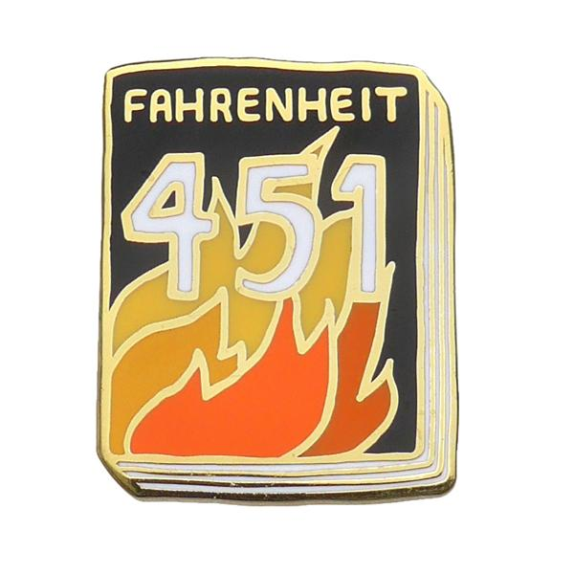
Thursday, November 15
- Fahrenheit 451 Test
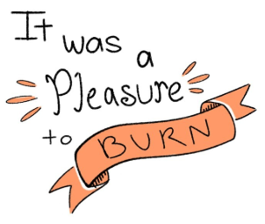

Supplemental material
and texts will also be read, studied, and assessed throughout this unit. Make sure to be studying not just the novel content, but supplemental materials as well.

*Reading quizzes and checks can be expected at any given
point during the unit; make
sure that you are keeping up with your nightly reading.
**The readings listed are to
be done for homework on the night they are listed.

Unit Foci: elements of
dystopian literature, theme, censorship,
equality, allegory, allusions, figurative language, symbolism, and historical content

