How to Study SAT Vocab the Right Way: The Waterfall Method
I call the way I study SAT vocab the Waterfall Method. This method essentially forces you to focus on words you don't know while preventing you from wasting time on words you already know. It's based on a proven memorization technique called Spaced Repetition.
Start with a stack of 30-50 vocab words (you can use as few as 15):Review each card. If you know the definition right away, put it in a Know It pile. If you struggled to remember the definition, put it in a Struggled pile. You'll end up with two stacks of word cards: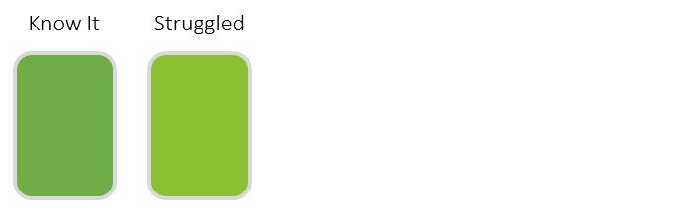Pick up the Struggled pile and repeat the process. The Struggled pile will have fewer words than your Starting Stack does. Put the words you know this time around into a second Know It pile and the words you're still struggling with in a new Struggled pile.
You should now have three separate stacks of cards: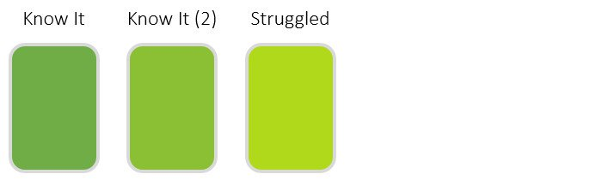
Keep repeating this process until you have just one to five words left in your last Struggled pile: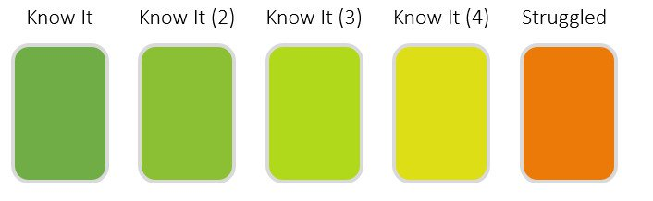 I call this method the Waterfall Method because we essentially have a cascading waterfall, in which words that are really hard for you keep tumbling into farther and farther piles.
Theoretically, at this point you should know nearly all the words in the entire set. Now, we're going to go back up the waterfall.
Combine your last Struggled pile with your last Know It pile. This will become your Working Pile: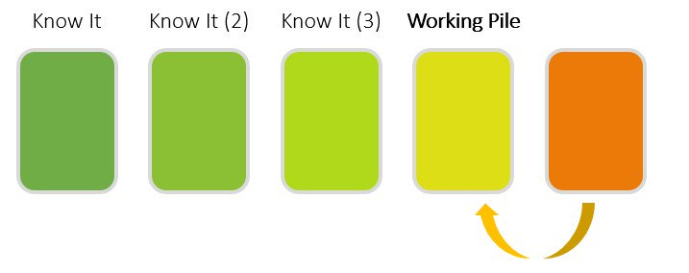Now, review all the words in this pile. If you forget any words, go through all of them again. Yep—this is harsh, but it's the only way you're going to memorize all the words. You'll need to be strict about making sure you learn each and every word.
Once you've remembered all the words, combine this pile with the next highest pile:
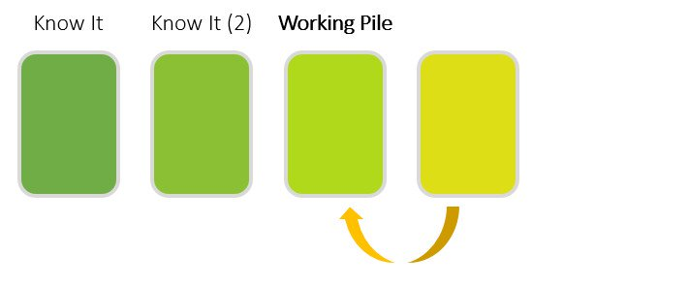At the very end, you should end up back with a Starting Stack. And you'll know every single word Why Does the Waterfall Method Work So Well?
The reason that this method is so effective is that you'll review the hardest words for you more than 10 times more often than easy words.
Most students just go through vocab lists from front to back. They might already know half the list, but they spend equal time on words they know and words they don't know (but really, reallyneed to learn).
Now that you've learned how to use the Waterfall Method, you'll be a smarter SAT studier and can concentrate far more on getting down the hardest vocabulary words for you.

