Ms. Mitchell



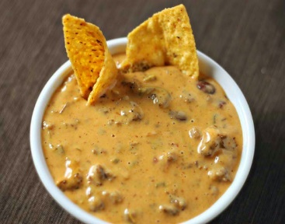

The memories that make you stop and smile no matter what you are doing.

A fiancé that you have loved since you were 13.

Cousins that have always felt more like siblings,

And the heartbreak of when one of those siblings dies.

Neighbors who are that sisters that you never had.

Being the Polly Pocket in her pick up truck.

Becoming the University of Georgia head coach every Saturday and the need to mourn every loss and celebrate every win.

Teachers that inspired you to become one yourself and

Students who make you want to laugh and cry at the same time.

Hot Cheetos, wings, and queso that make you dance a little bit every time you eat them.

The memories that make you stop and smile no matter what you are doing.

