Below you will find the directions for the different logins used for this class!

Remind 101 Login Information:
Each class has a different code that they need to text.
Send the following message to the number 81010:
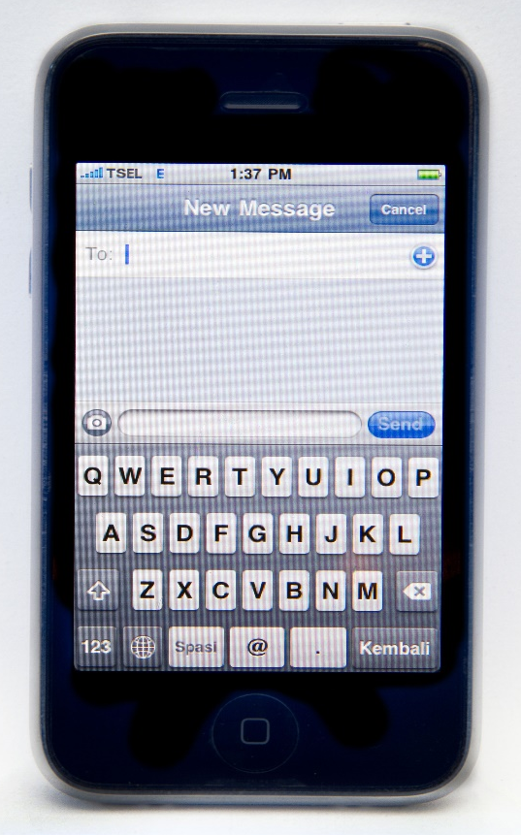
1st period - @1rollmitch
3rd period- @3rollmitch
81010
4th period- @4rollmitch
Class-code!
6th period- @6rollmitch
7th period - @7rollmitch

Turnitin.com Login Directions
1. Create an account
You MUST use your SCHOOL email account.
studentID#@fcstu.org
2. Your password should be
First name capitalized and the year you were born
EX: Alex2005
***If you choose a different password then I will not be able to help you log on later!***
Period | Enrollment Key | Class ID
1st | 1Mitchell | 18581136
3rd | 3Mitchell | 18581148
4th | 4Mitchell | 18581157
6th | 6Mitchell | 18581166
7th | 7Mitchell | 18581171

Launchpad Login
Step 1: Go to Launchpad.fultonschools.org

Step 2: Click on the first link

Step 3: Log in using your school email
Username: Lunch Number
Password: birthday mm/dd/yyyy

Step 4: Click on the Pearson Easybridge icon (green with a white P)

Step 5: Click on the book that you need to use

